**Learning Transportation Network Analysis:**

*Module 1.1: Introduction with the West Jordan Network*

**Prepared by Dana Alsader and Jinjin Tang**

**This document was prepared using a version of NeXTA released on** [**February 7th, 2013**](http://nexta.googlecode.com/files/Internal_release_02_07_2013.zip)**. If you use an older/newer release of NeXTA, the instructions may not accurately describe the steps required to complete this learning document. Please use the latest release of NeXTA when working with this document, and we will try to update the content to reflect new changes made within NeXTA.**

**Goal:**

This assignment will require preparing two different traffic simulation models - one in the initial condition (without the work zone), and one in the work zone condition. In preparing these two models, you will acquire the skills described in the following learning objectives.

**Learning Objectives:**

1. Understand how to view/edit network attributes in NeXTA and GIS
2. Run a basic traffic simulation, comparing two different scenarios
3. Understand how basic network attributes affect traffic simulation results

[**Example:**](https://docs.google.com/document/d/1nHKOo8buhCReS41IUFAdzhXIAHmijU1TfdR98i-HQk8/edit)

The City of West Jordan will soon start a construction project to replace stormwater pipes under 9000 South between 1300 West and 700 West. In order to complete this project, 9000 South must be partially closed (from 2 lanes in each direction to 1 lane in each direction) to create a safe work zone for the repair crews. You (and an optional partner) have been tasked with using a Dynamic Traffic Assignment (DTA) model to evaluate the travel impacts (congestion, delay, etc.) associated with partially closing 9000 South. This assignment will require preparing two different traffic simulation models - one in the initial condition (without the work zone), and one in the work zone condition. In preparing these two models, you will acquire the skills described in the following learning objectives

**Step 1: Download and Open the West Jordan Network**

Before going into too much detail, first makes sure you’re using the most up-to-date version of NeXTA, and open the West Jordan network.

**Step 1.1:** Download Lesson 1 dataset using the following link:

<https://github.com/xzhou99/dtalite_software_release/tree/gh-pages/2_Data_Sets>

**Step 1.2:** Extract the zip file to a known location on your computer, and open the NEXTA.exe file.

**Step 1.3:** Open the West Jordan Network in NeXTA

In NeXTA, go to File -> Open Traffic Network Project

In the Internal Release folder, go to the sample data sets/Salt_Lake_City_West_Jordan folder, select the **Base_Condition.tnp** file, and click **Open**.

NeXTA will open the network, and display the **File Loading Status window**. The File Loading Status window displays information about the network currently open in NeXTA, including information about the number of links, nodes, and zones/activity locations in the network. This window can also be accessed by going to **File -> Check Data Loading Status**.

**Problem 1:**  How many nodes are in the West Jordan network? How many zones are in the West Jordan network

**Step 2: Viewing/Editing Network Attributes in NeXTA**

**Definitions of links, nodes and zones**:

Network objects primarily consist of links, nodes, and zones. A driver starts and ends their trip at a zone, traveling along road segments (links) between the origin and destination. Links are connected together at nodes, where a node may represent an intersection or a simple connection between two road segments. Since vehicles only travel along links, passing nodes between their origin and destination, trip details (such as travel time, distance, speed, etc.) are heavily dependent upon link and node attributes. The most important link attributes are typically link length, speed limit, number of lanes, and capacity. Since nodes typically represent intersections, their important attributes typically include node control type (signalized intersection, stop-controlled intersection, no control, etc.) and traffic signal-related attributes.

**Section goal:**

This section will quickly explain how to view and edit these network object attributes.

**Step 2.1:** To quickly view most link or node attributes, simply select a link or node using the Select Object tool, and look at the attributes in the GIS Layer Panel in the bottom right corner of the screen. (Note, not all attributes are displayed in this panel.)

**Link Attributes**                     **Node Attributes**

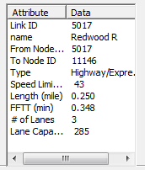                        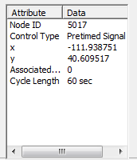

Alternatively, after selecting the link or node, right-click near the object and select either Edit Link Properties or Node Properties. Selecting Edit Link Properties opens the Link Properties dialog box, shown below. These dialog boxes offer the ability to edit individual link and node attributes quickly and easily - simply replace the text/values in the appropriate field, select OK, and click the Save button https://lh6.googleusercontent.com/eIhAgLJHcz6ZgcnhUqyCuPrB2gjMRoMqEALA5pxt9Xk_h6mITubGY91uSBiGZ-xQBHlDEzN6D8hI0zTGxy5mqd0Ty-uZQE6az7SQMC9FD3QmHzpgaMwMsnuB7za-omRGcaMShIWPbbbevZ8dxQon the Tool Bar to save your changes to the network.

**Problem 2:** What is the speed limit along 9000 south? How many lanes are present along 9000 South in the Base Condition model

**Problem 3:** What is link capacity? How is it different from lane capacity

**Problem 4:** Describe the link capacity on Redwood Road in the West Jordan Network (how link capacity varies by location, point out bottlenecks, etc.). It might also be a good idea to include the average link capacity and/or use a histogram. **Hints:** You can find file input_link.csv in the project folder (NEXTA menu->file->open project folder->locate input_link.csv) and use Excel to generate the histogram for the link capacity for all links with names of Redwood.

**Step 3: Running a Traffic Simulation**

Since the objective is to evaluate the effects of the work zone located on 9000 south, we must prepare two networks - one with work zone and one without the work zone (initial condition). Before preparing the network, let’s run the traffic simulation for the initial condition to generate the simulation results which we will later use for comparison.

**Step 3.1:** Traffic simulations can be quite complex, with many different settings and options, but in this case the simulation settings have mostly been provided for us. To run the traffic simulation in NeXTA, simply click the https://lh3.googleusercontent.com/_VHSqkNGO1tpZiHXfI708Je3eQ4hjbHsYtdJToFDigmltM-dVAEc9fxWzJ9FXC1z9eHXZee10uAA_bdOdf_Ts67P7DznXERYnLP44aAw0O7-QzwFN3CFZWQ5ZcGfVbMxjlc-uri2Jtnc9cA9Agbutton on the MOE Toolbar. This will open a dialog box with simulation settings.

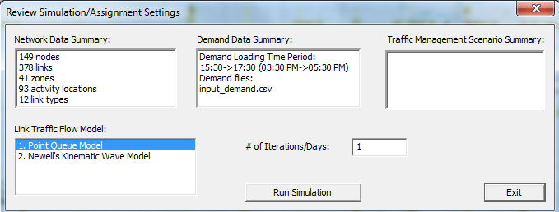

Please note that the current setting of **# of Iterations/Days** is 1 You can change it to more iterations/days, e.g. 30 iterations/days to obtain a converged network pattern. We’ll learn more about these settings in later lessons, but for now, simply press OK to start the simulation. Doing so will open the DTALite simulation window.

|  |
| --- |
| **Note:** If the executable cannot be run and outputs an error message such as “the application has failed to start because its side-by-side configuration is incorrect”, you need to install additional Microsoft Visual C++ 2015 Redistribution Package.  <http://www.microsoft.com/en-us/download/details.aspx?id=15336> for 64-bit operating system |

Allow the simulation to run until it is finished (the window will close automatically). Once complete, NeXTA will display another window describing the simulation run (shown below). Select **yes** to view the simulation summary file (output_summary.csv).

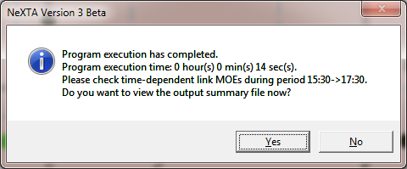

**Problem 5:** What is the number of agents/vehicles to be simulated, as reported in the output_summary.csv file

**Problem 6:** The first large table in the output_summary.csv file describes summary statistics for each iteration of the simulation. What was the average travel time, average trip time index, average speed, and network clearance time (in minutes) for the last iteration What pattern do you observe in the average travel times and speeds as the iteration number increases (Plots might be useful to display these patterns/trends.)

**Step 4: Create the Work Zone Network**

When creating comparison networks, it is often a good idea to create a copy of the network first. We usually do this because we want to preserve simulation results and initial network attributes, as well as to make comparison easier (we can open multiple networks in NeXTA at the same time).

**Step 4.1:** Copy the West Jordan Network to create the work zone model. First, go to File -> Open Project Folder in NeXTA. This will open the folder containing the input files for the West Jordan network. Browse to the sample_data folder in the Internal Release folder, which contains the West Jordan network. Copy the “Salt_Lake_City_West_Jordan” folder, and paste it within the same sample_data folder, and change the folder name to “West_Jordan_WZ”. Open this newly created folder and change the TNP file name from “Base_Condition.tnp” to “West_Jordan_WZ.tnp”.

**Step 4.2:** Open this new West_Jordan_WZ model in NeXTA (following Step 1). Then, following the instructions in Step 2, reduce the number of lanes on all links between Node 1 and Node 3 (in both directions) to 1 lane, representing the work zone condition in which one lane is closed in each direction on 9000 South. **Remember to save the network after you finish editing the network to save your changes.**

**Step 4.3:** Run the traffic simulation again, following the instruction in Step 3. Open the output summary file to answer the following questions.

**Problem 7:** Similar to Problem 6, use the first large table in the output_summary.csv file to find the average travel time, average trip time index, average speed, and network clearance time (in minutes) for the last iteration? Do you notice many differences in these values compared to the results for the “no work zone” model

**Step 5: Compare the Simulation Results for Both Networks (with and without work zone)**

**Step 5.1:** Close NeXTA. Open NEXTA_64exe again, and go to File -> Close to close the empty network that is shown initially. Go to File -> Open to open the West_Jordan_WZ network, and close the File Loading Status Window when it opens. Then open the Base_Condition network (without work zone), and close the File Loading Status Window again.

**Step 5.2:** We now have two networks loaded in NeXTA at the same time. Go to the Window menu and select Tile Vertically, then also select Synchronized Display. This will allow us to move to the same locations in both networks at the same time, and allow us to directly compare simulation results at those locations. If you followed these instructions correctly, your display should look like the figure below.

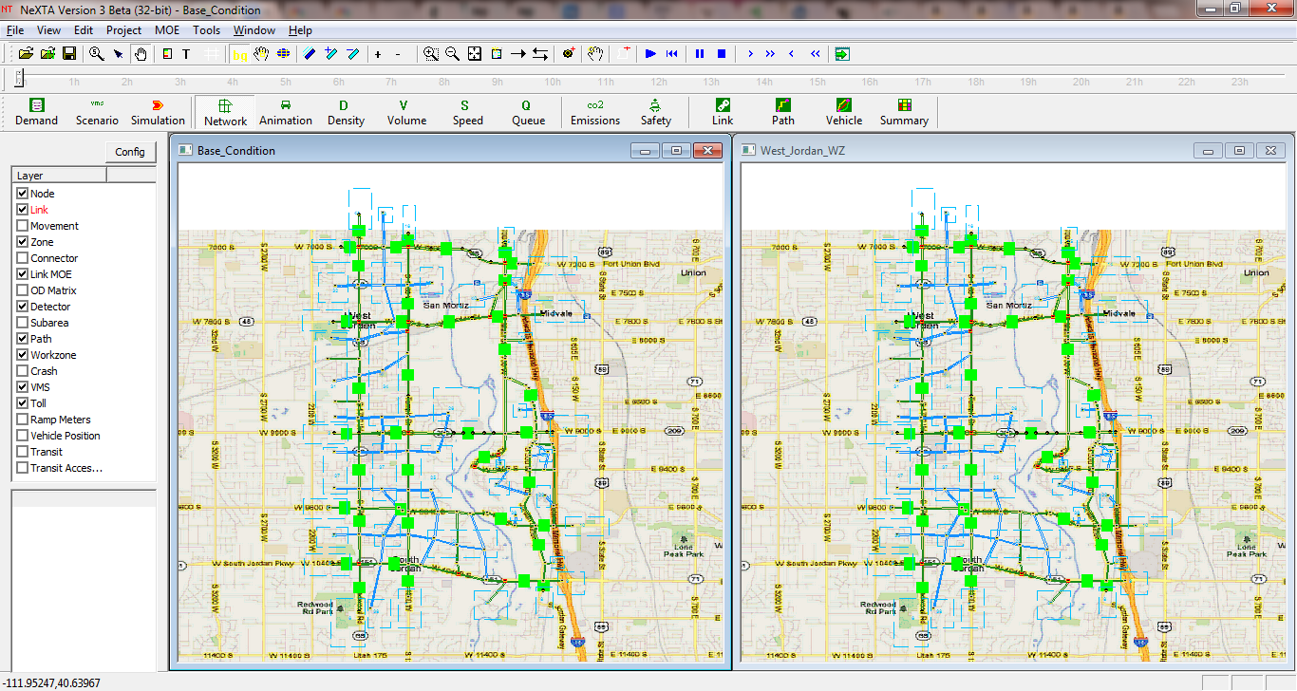

**Step 5.3:** To compare simulation results in much higher detail, we can use the Link MOE display in NeXTA. Select the Link MOE layer in GIS Layer Panel (make sure it is turned on, and is highlighted in red by clicking on the Link MOE text label), and zoom in to Node 5022 (you can use the search function with CRTL+F if you have trouble finding it). Use the Select Object tool again to select the link going from Node 11124 to Node 5022, opening the Link MOE window. Your display should look similar to the figure below (you need to open two projects at the same time to see MOE time series for both projects) .

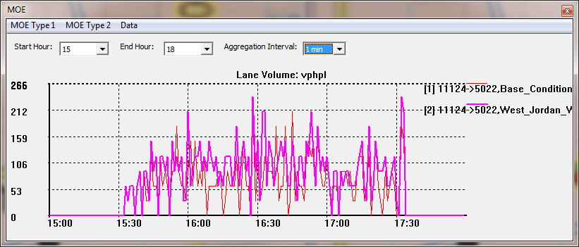

This plot shows the number of vehicles passing through this link (in vehicles per hour per lane) for both simulations (the red line represents the simulation without work zone, and the purple line represents the simulation with work zone conditions). We can show different MOEs by selecting different options in the MOE Type 1 menu, and smooth the data by adjusting the aggregation interval. Switching to the 15 minute aggregation interval produces the following plot.

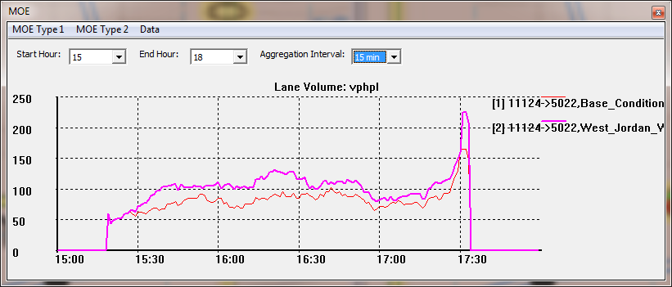

**Problem 8:** Following the procedure described in Step 5, use screen captures to provide Link MOE plots for Lane Volume and Speed (in MPH), with 15 minute aggregation intervals, for both links between Node 1 and Node 2 (both directions). This should result in 4 images.

**Problem 9:** From the plots generated in Problem 8, did you notice any differences in speed and volume on these links between the two networks (with and without the work zone)? Do the differences in speed/volume make sense? Does one direction of travel experience more congestion

**Step 6: Visualize Simulation Results in Google Earth, Google Fusion Tables, and QGIS**

**Preliminary Step:** Download and install QGIS (or use ArcGIS if you prefer). (<http://qgis.org/downloads/QGIS-OSGeo4W-1.8.0-1-Setup.exe>)

**Problem 10:** (bonus question) Following the instructions in the [Learning Module document](https://docs.google.com/document/d/1nHKOo8buhCReS41IUFAdzhXIAHmijU1TfdR98i-HQk8/edit), export the Work Zone network to a KML file, and open the network in Google Earth. Provide a screen capture to show your exported network.

**Problem 11: (bonus question, as the latest NEXTA might generate different file format)** Following the instructions in the [Learning Module document](https://docs.google.com/document/d/1nHKOo8buhCReS41IUFAdzhXIAHmijU1TfdR98i-HQk8/edit), export the Work Zone network to a GIS file, and open the network in QGIS (or ArcGIS, if you prefer). Provide a screen capture to show your exported network.

**Problem 12:** (bonus question) Following the instructions in the [Learning Module document](https://docs.google.com/document/d/1nHKOo8buhCReS41IUFAdzhXIAHmijU1TfdR98i-HQk8/edit), upload the Work Zone network’s input_link.csv file as a Google Fusion Table in Google Drive, and open the Map view. Change the link width in the map to display based on the number of lanes. (Hint: On the Map tab, click the arrow on the tab, select “Change map styles”, and use Buckets to make the link widths dependent upon the number of lanes - an example is provided below). Provide a screen capture to show your exported network.

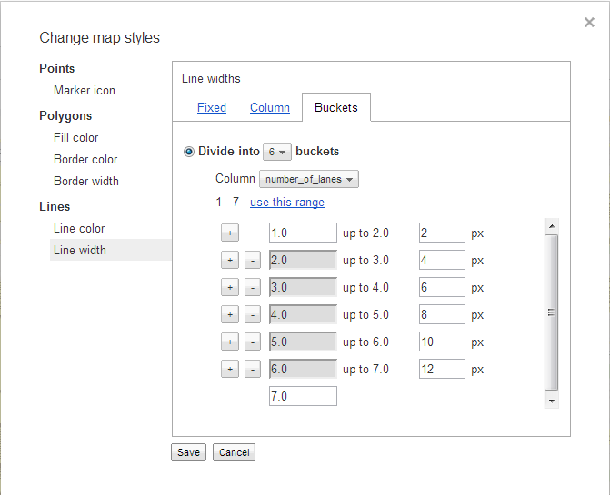

**Recommendations:**

*If you find that some instructions/questions are unclear or have recommendations for improvement, please add a comment to this online document (Insert → Comment, or use the Comments button at the top-right corner), and/or contact the author at xzhou99@gmail.com, so that we can improve this working document for you and other users/students. Thanks!*

**Sources**:

**White pape**r on DTALite:

DTALite: A queue-based mesoscopic traffic simulator for fast model evaluation and calibration

<http://www.tandfonline.com/doi/full/10.1080/23311916.2014.961345#.VGy47vnF_o9>

**YouTube Video** for additional instructions

<https://www.youtube.com/watch?v=taIlhCl2Wic>